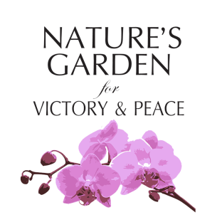

Poetry Slam Entry Application

Applicant Information
Full Name: |  |  |  | Date:
 | Last | First | M.I.

Grade (Circle) : | Freshman Sophomore Junior Senior

High School: __________________________________ Sex (Circle) : Male Female Prefer Not to Identify

Phone: |  | Email

More About You

Hobbies:

_______________________________________________________________________________________

________________________________________________________________________________________

School Activities/ Memberships:

______________________________________________________________________________________

Performance Type (Circle): Rap Poem Spoken Word Other: _______________________________

Will You be Using Small Props: Yes No

If Yes, Please List & Describe ____________________________________________________________

Will you use background music? Yes No

I have read, understand, and agree to comply with the rules of Nature’s Garden Poetry Slam contest. The information above is accurate to my knowledge.
Signature: |  | Date:

